Lab 1

# Ice cream and one thing to get done before January

Brilliant Nguyen loves chocolate ice cream. He wants to succeed this semester before the start of the winter term

Colin McGarw loves vanilla ice cream. He wants to go rock climbing outdoors before January

# Java and C

Java Source code

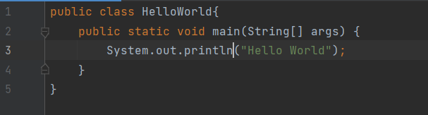

Java Directory Listing

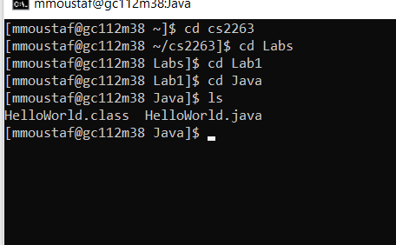

Java Output

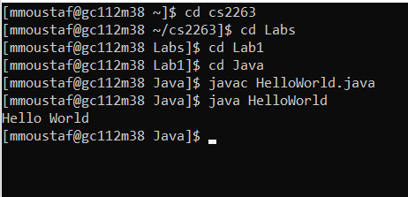

C Source Code

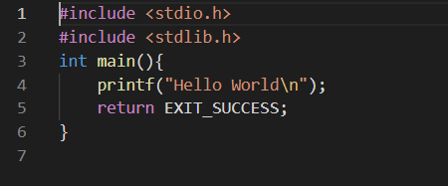

C Directory Listing

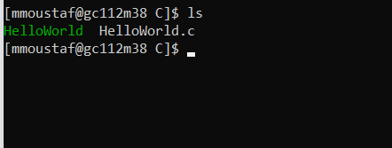

C Output

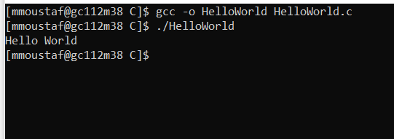

# 1C

When compiling a Java program, a .class file is created which can only be executed by a Java Runtime Environment. A .class file contains bytecode (binary program code executable by a Java Virtual Machine). When compiling a C program with gcc -o it results in an executable program. Java runs across a VM which is standardized across all platforms that it runs on, while C depends on the hardware of the machine.[1]

# digitOnes

digitOnes Source Code

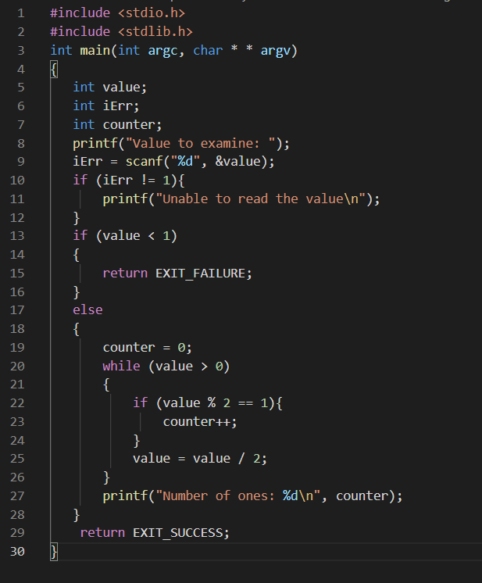

digitOnes Directory

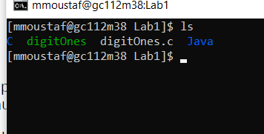

digitOnes Compile and Testing

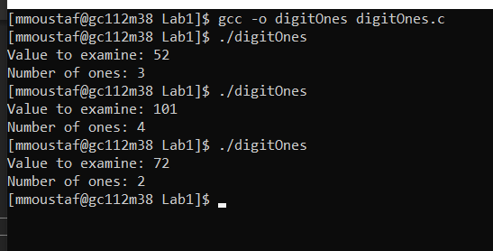

1. [CLASS File Extension - What is a .class file and how do I open it? (fileinfo.com)](https://fileinfo.com/extension/class)